Regulatory Committee
Meeting to be held on 18th November 2020

Part I

Electoral Division affected:
Lancaster Rural East

Wildlife and Countryside Act 1981
Definitive Map Modification Order Investigation
Addition of Footpath from Wennington Road to Home Farm Close, Wray with Botton, Lancaster
File No. 804-620
(Annex ‘A’ refers)

Contact for further information:
Simon Moore, Paralegal Officer, County Secretary and Solicitors Group, simon.moore@lancashire.gov.uk, 01772 531280
Jayne Elliott, Public Rights of way Definitive Map Officer, Planning and Environment, jayne.elliott@lancashire.gov.uk, 01772 537663

Executive Summary

Application for the addition of a Footpath from Wennington Road to Home Farm Close, Wray with Botton to the Definitive Map and Statement of Public Rights of Way, in accordance with File No. 804-620.

Recommendation

That the application for the addition of a Footpath from Wennington Road to

Home Farm Close, Wray with Botton, in accordance with File No. 804-620, be accepted.

That an Order be made pursuant to Section 53 (2)(b) and Section 53 (3)(b)

and/or Section 53 (3)(c)(i) of the Wildlife and Countryside Act 1981 to add a Footpath from Wennington Road to Home Farm Close, Wray with Botton on the Definitive Map and Statement of Public Rights of Way as shown on Committee Plan between points A-B-C.

That being satisfied that the higher test for confirmation can be met the Order

be promoted to confirmation.

Background

An application under Schedule 14 of the Wildlife and Countryside Act 1981 has been received for the addition of a Footpath from Wennington Road to Home Farm Close, Wray in Botton to be recorded on the Definitive Map and Statement of Public Rights of Way.

The county council is required by law to investigate the evidence and make a decision based on that evidence as to whether a public right of way exists, and if so its status. Section 53(3)(b) and (c) of the Wildlife and Countryside Act 1981 set out the tests that need to be met when reaching a decision; also current Case Law needs to be applied.

An order will only be made to add a public right of way to the Definitive Map and Statement if the evidence shows that:
- A right of way “subsists” or is “reasonably alleged to subsist”

An order for adding a way to or upgrading a way shown on the Definitive Map and Statement will be made if the evidence shows that:
- “the expiration… of any period such that the enjoyment by the public…raises a presumption that the way has been dedicated as a public path or restricted byway”

When considering evidence, if it is shown that a highway existed then highway rights continue to exist (“once a highway, always a highway”) even if a route has since become disused or obstructed unless a legal order stopping up or diverting the rights has been made. Section 53 of the Wildlife and Countryside Act 1981 makes it clear that considerations such as suitability, the security of properties and the wishes of adjacent landowners cannot be considered. The Planning Inspectorate’s website also gives guidance about the interpretation of evidence.

The county council’s decision will be based on the interpretation of the evidence discovered by officers and documents and other evidence supplied by the applicant, landowners, consultees and other interested parties produced to the county council before the date of the decision. Each piece of evidence will be tested and the evidence overall weighed on the balance of probabilities. It is possible that the council’s decision may be different from the status given in any original application. The decision may be that the routes have public rights as a footpath, bridleway, restricted byway or byway open to all traffic, or that no such right of way exists. The decision may also be that the routes to be added or deleted vary in length or location from those that were originally considered.

Consultations

Lancaster City Council

In response to the consultation Lancaster City Council planning highlighted a related planning condition and provided an extract of same, included below. They stated that: "To formally recognise the footpath as a public right of way would reflect the requirement of condition 13 on planning permission 99/00664/FUL – ‘erection of one dwelling’ on land between no 30 & 34 Wennington Road (see below) and confirm its rationale for its imposition (i.e. the City Council’s view of the importance of this pedestrian link)."

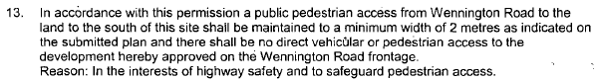

Wray with Botton Parish Council

The parish council are the applicants in this matter and the registered owners of the land between point B and point C.

Applicant/Landowners/Supporters/Objectors

The evidence submitted by the applicant/landowners/supporters/objectors and observations on those comments are included in Advice – Head of Service – Legal and Democratic Services Observations.

Advice

Head of Service – Planning and Environment

Points annotated on the attached Committee plan.

Point | Grid Reference (SD) | Description
A | 6036 6775 | Open junction with Wennington Road
B | 6038 6773 | End of tarmac and rear boundary of 32 Wennington Road
C | 6040 6770 | Open junction with Home Farm Close

Description of Route

The application route commences at a point on Wennington Road in the village of Wray (point A on the Committee plan). It runs south-east on a 2m wide tarmac surface path between the walls of properties numbered 30 and 32 Wennington Road with access off the route leading to the front of 32 Wennington Road.

From the rear of the house (32 Wennington Road) the route then opens up and crosses a tarmac area to point B from where it continues as a compact stone surfaced track to point C. At point C the application route meets Home Farm Close and immediately to the west of point C is an access point into a recreation ground/school field.

The total length of the route is 70 metres.

Map and Documentary Evidence

A variety of maps, plans and other documents were examined to discover when the route came into being, and to try to determine what its status may be.

Document Title | Date | Brief Description of Document & Nature of Evidence
Yates’ Map  of Lancashire | 1786 | Small scale commercial map. Such maps were on sale to the public and hence to be of use to their customers the routes shown had to be available for the public to use. However, they were privately produced without a known system of consultation or checking. Limitations of scale also limited the routes that could be shown.
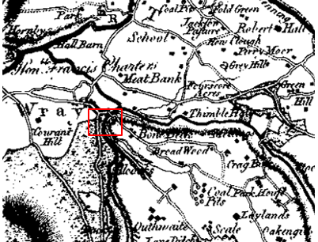
Observations |  | Wennington Road can be seen but Home Farm Close is not shown. The application route is not shown but nor are other footpaths.
Investigating Officer's Comments |  | The application route probably did not exist in 1786.
Greenwood’s Map of Lancashire | 1818 | Small scale commercial map. In contrast to other map makers of the era Greenwood stated in the legend that this map showed private as well as public roads and the two were not differentiated between within the key panel.
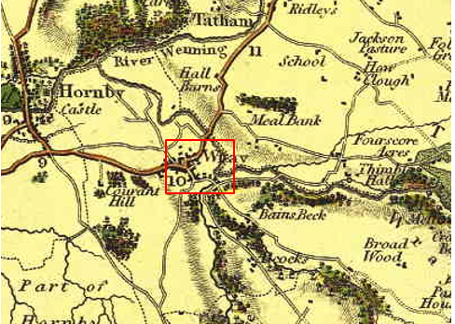
Observations |  | Wennington Road can be seen but Home Farm Close is not shown. The application route and other footpaths are not shown.
Investigating Officer's Comments |  | The application route probably did not exist in 1818.
Hennet's Map of Lancashire | 1830 | Small scale commercial map. In 1830 Henry Teesdale of London published George Hennet's Map of Lancashire surveyed in 1828-1829 at a scale of 7½ inches to 1 mile. Hennet's finer hachuring was no more successful than Greenwood's in portraying Lancashire's hills and valleys but his mapping of the county's communications network was generally considered to be the clearest and most helpful that had yet been achieved.
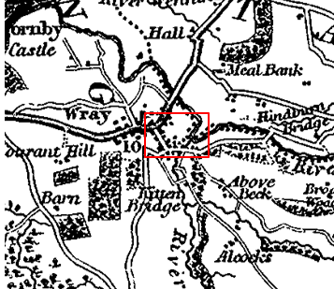
Observations |  | Wennington Road can be seen but not Home Farm Close. The application route and other footpaths are not shown.
Investigating Officer's Comments |  | The application route probably did not exist in 1830.
Canal and Railway Acts |  | Canals and railways were the vital infrastructure for a modernising economy and hence, like motorways and high speed rail links today, legislation enabled these to be built by compulsion where agreement couldn't be reached. It was important to get the details right by making provision for any public rights of way to avoid objections but not to provide expensive crossings unless they really were public rights of way. This information is also often available for proposed canals and railways which were never built.
Observations |  | There are no existing or proposed canals or railways in the area crossed by the application route.
Investigating Officer's Comments |  | No inference can be drawn with regards to the existence of public rights.
Tithe Map and Tithe Award or Apportionment  CRO Ref: DRB1/214 | 1849 | Maps and other documents were produced under the Tithe Commutation Act of 1836 to record land capable of producing a crop and what each landowner should pay in lieu of tithes to the church. The maps are usually detailed large scale maps of a parish and while they were not produced specifically to show roads or public rights of way, the maps do show roads quite accurately and can provide useful supporting evidence (in conjunction with the written tithe award) and additional information from which the status of ways may be inferred.
Observations |  | The Tithe Map for Wray has not been examined as there is no map evidence suggesting the existence of the route at this time.
Investigating Officer's Comments |  | No inference can be drawn.
Inclosure Act Award and Maps |  | Inclosure Awards are legal documents made under private acts of Parliament or general acts (post 1801) for reforming medieval farming practices, and also enabled new rights of way layouts in a parish to be made. They can provide conclusive evidence of status.
Observations |  | There is no Inclosure Award for the area crossed by the application route.
Investigating Officer's Comments |  | No inference can be drawn with regards to the existence of public rights.
6 Inch Ordnance Survey (OS) Map | 1847 | The earliest Ordnance Survey 6 inch map for this area surveyed in 1844-45 and published in 1847.
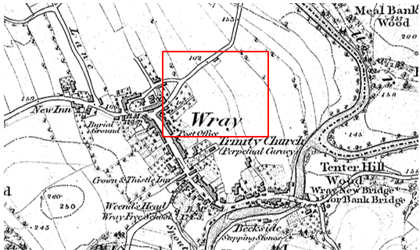
Extract of map
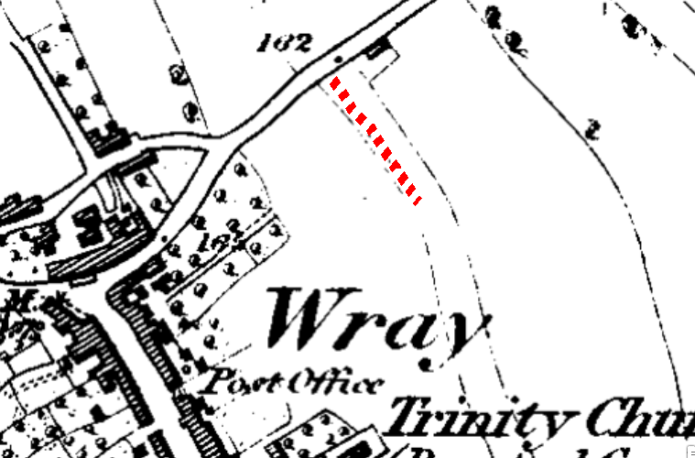
Extract of map with Application route overlaid in red
Observations |  | The application route is not shown. Wennington Road is shown as a main route through the village but Home Farm Close is not shown. The land crossed by the application route is within a thin strip of land.
Investigating Officer's Comments |  | The application route did not exist in 1847.
25 Inch OS Map Sheets 25-12 and 25-16 | 1891 | The earliest OS map at a scale of 25 inch to the mile. Surveyed in 1889-1890 and published in 1891.
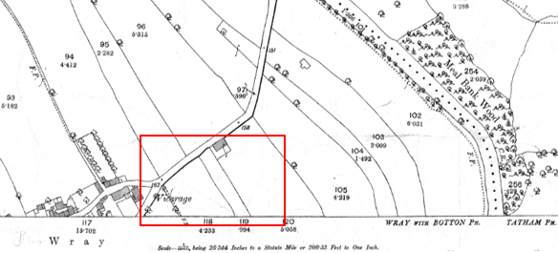
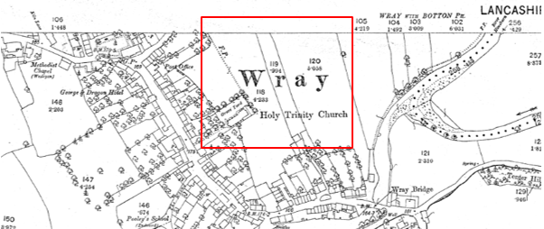
Observations |  | Wennington Road existed but Home Farm Close is not shown.  The land crossed by the application route crosses land forming part of a long narrow fenced field (field parcel number 119) but the application route is not shown.
Investigating Officer's Comments |  | The application route did not exist in 1891.
25 inch OS Map  Sheets 25-12 and 25-16 | 1913 | Further edition of the 25 inch map surveyed in 1889-1890, revised in 1910 and published in 1913.
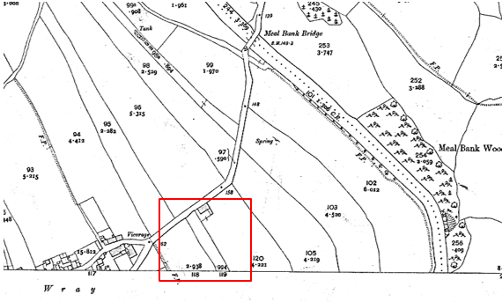
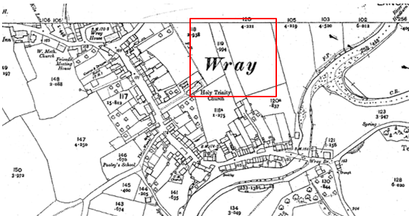
Observations |  | The application route is not shown and the land crossed by the route does not appear to have altered since the earlier editions of the 6 inch and 25 inch OS maps were surveyed.
Investigating Officer's Comments |  | The application route did not exist in 1910.
Finance Act 1910 Map | 1910 | The comprehensive survey carried out for the Finance Act 1910, later repealed, was for the purposes of land valuation not recording public rights of way but can often provide very good evidence. Making a false claim for a deduction was an offence although a deduction did not have to be claimed so although there was a financial incentive a public right of way did not have to be admitted.  Maps, valuation books and field books produced under the requirements of the 1910 Finance Act have been examined. The Act required all land in private ownership to be recorded so that it could be valued and the owner taxed on any incremental value if the land was subsequently sold. The maps show land divided into parcels on which tax was levied, and accompanying valuation books provide details of the value of each parcel of land, along with the name of the owner and tenant (where applicable).  An owner of land could claim a reduction in tax if his land was crossed by a public right of way and this can be found in the relevant valuation book. However, the exact route of the right of way was not recorded in the book or on the accompanying map. Where only one path was shown by the Ordnance Survey through the landholding, it is likely that the path shown is the one referred to, but we cannot be certain. In the case where many paths are shown, it is not possible to know which path or paths the valuation book entry refers to. It should also be noted that if no reduction was claimed this does not necessarily mean that no right of way existed.
Observations |  | The District Valuation records have not been obtained as there is no map or user evidence from the early 1900s suggesting that the application route existed at that time.
Investigating Officer's Comments |  | No inference can be drawn.
25 Inch OS Map | C.1930 | Further edition of 25 inch map.
Observations |  | A copy of the OS 25 inch (and 6 inch) map prepared in the 1930s for the area crossed by the application route is not available to view.
Investigating Officer's Comments |  | No inference can be drawn.
Aerial Photograph | 1940s | The earliest set of aerial photographs available was taken just after the Second World War in the 1940s and can be viewed on GIS. The clarity is generally very variable.
Observations |  | There is no aerial photograph available to view from the 1940s within the county council's records.
Investigating Officer's Comments |  | No inference can be drawn with regards to the existence of the application route or public rights.
6 Inch OS Map  Sheet 66NW | 1956 | The OS base map for the Definitive Map, First Review, was published in 1955 at a scale of 6 inches to 1 mile (1:10,560). This map was revised before 1930 and is probably based on the same survey as the 1930s 25-inch map.
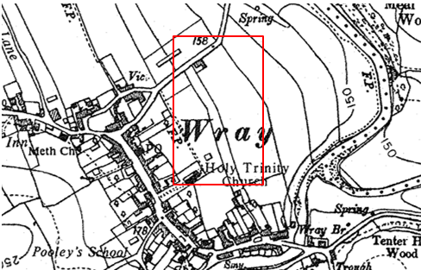
Observations |  | Home Farm Close and the application route are not shown and the land crossed by the route does not appear to have altered since the earlier editions of the 6 inch and 25 inch OS maps were surveyed in the early 1900s.
Investigating Officer's Comments |  | The application route did not exist in the 1930s when the survey on which the map is based was carried out.
Aerial photograph | 1960s | The black and white aerial photograph taken in the 1960s and available to view on GIS.
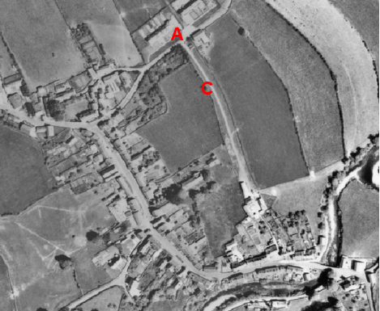
Observations |  | Home Farm Close does not exist but the aerial photograph clearly shows a track extending from Wennington Road at point A consistent with the application route passing through point C and continuing directly to Home Farm from where it appears to continue through to Main Street.
Investigating Officer's Comments |  | The application route existed in the 1960s and appeared capable of being used. It is not known from looking at the photograph whether access beyond point C was just to the farm or whether it was possible to continue through to Main Street.
Deed of Grant of a right of way at Wray | 1970 | A copy of a Deed of Grant of a right of way submitted by the applicant. The original agreement has been deposited in the county council Deed room and is dated 2nd April 1970 together with a supplemental Deed dated 6 September 1995
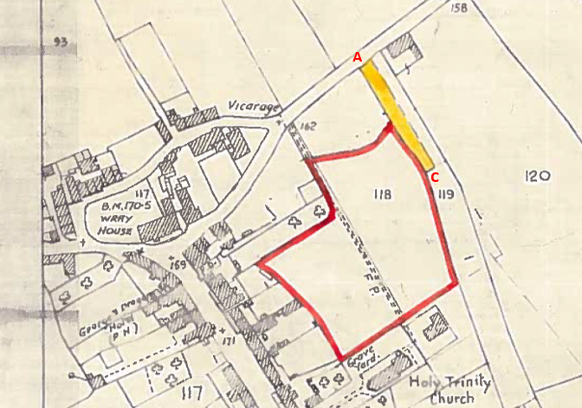
1970 Deed Plan
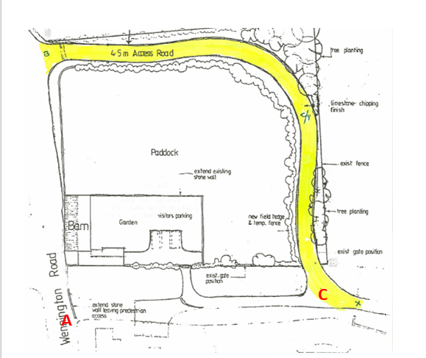
1995 Deed Plan
Observations |  | The 1970 Deed relates to the granting of a right of way over land coloured yellow on the plan forming part of the agreement. The agreement was made on 2 April 1970 between Mrs P D Holt and Lancashire County Council and contained in it is the provision that Lancashire County council would construct a road on the land coloured yellow and would thereafter maintain and keep it in good repair. The Deed provides for a right of access with or without horses carts and vehicles from the land coloured red on the plan along the land coloured yellow (the road to be constructed by the county council). There is no reference to the dedication of public rights but the road to be constructed is consistent with the application route between point A and point C.  The land referred to as being coloured red on the plan is owned by Lancashire County Council and is the primary school playing field immediately west of the application route. Access onto the playing field is currently available from point C on the junction of the application route and Home Farm Close.  The 1995 Supplemental Deed relates to the original access agreement and explains that the grantor (Mrs Holt) had requested that the county council agree to vary the route of the said right of way to that shown coloured yellow on the 1995 plan) and that the county council had agreed. The plan contained within the agreement indicates that the wall on Wennington Road was to be extended in proximity of point A but notes that a gap was to be left for pedestrian access. There is no reference to the dedication of public rights within the document.
Investigating Officer's Comments |  | No inference can be drawn regarding the existence of public pedestrian rights. In 1970 the access to the property was for Lancashire County Council as owners of that land not as Highway Authority. That right included vehicular access but did not imply there were no public pedestrian rights.  The 1995 variation of the route provided for the construction of a new private access route which subsequently became part of Home Farm Close which was adopted in 2004. At the time of the agreement however it appears that the route was a private access route to allow the county council to access land in its ownership.  The 1995 plan indicates that pedestrian access was to be retained at point A and both the 1970 and 1995 plans indicate that access may have been possible along the application route during that time. However neither agreement conveys public rights of access on foot.
1:2500 OS Map  SD 6067-6167 | 1973 | Further edition of 25 inch map reconstituted from former county series and revised in 1972 and published in 1973 as national grid series.
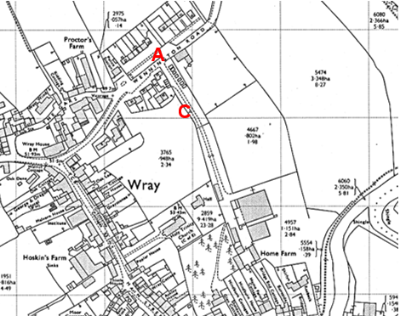
Observations |  | The application route existed as a substantial track from point A where access to it is shown as unrestricted. Between point A and point C the route appears to provide access to a row of buildings – possibly garages. Beyond point C the route is shown continuing as a track (gated just south east of point C) to provide access to Home Farm. South of the farm gated access continuing through to Main Street may have been possible along a thin strip of land adjacent to Bridge End cottage.
Investigating Officer's Comments |  | The application route existed in the 1960s and formed part of an access track possibly to some garages and also to Home Farm. The route appears to have been wide enough for vehicular access. South of the farm a narrow bounded strip is evident which may have provided pedestrian access through to Main Street.
Planning Permission for the construction of 32 Wennington Road  Ref: 99/00664/FUL | 1999 | A copy of the Planning Permission granted in respect of the construction of 32 Wennington Road was obtained from Lancaster City Council.
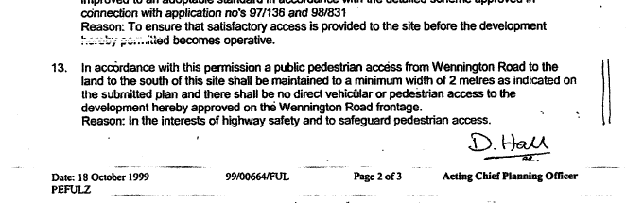

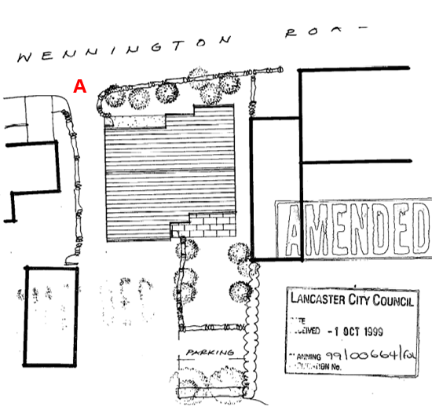

Observations |  | A planning application was submitted to Lancaster City Council on 15 July 1999 for the erection of 1 dwelling house (32 Wennington Road) on the strip of land crossed by the application route.  Planning permission was granted by the City Council on 18 October 1999 and included a number of conditions. The thirteenth condition listed referred to the fact that a public pedestrian access was to be maintained from Wennington Road to the land to the south of the site. This route was to be a minimum of 2 metres wide.
Investigating Officer's Comments |  | When planning permission was granted it was subject to maintaining public access from Wennington Road to the land to the south, i.e. along the route between point A and point C and the condition does not make clear whether this was recognising existing public access or the creation of a public access route although it could be argued that use of the word 'maintained' suggests the former.  Planning permission specifically provides for this access route which was required to be a minimum of 2 metres wide and the site evidence and user evidence suggest that this requirement was complied with.
Aerial Photograph | 2000 | Aerial photograph available to view on GIS.
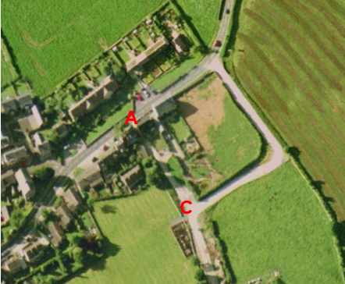
Observations |  | This photograph was taken within 12 months of planning permission being granted to build the house. The property does not appear to have been constructed but the application route can be clearly seen between point A and point C. Home Farm Close is shown as well as the access onto the playing field (immediately south of point C).
Investigating Officer's Comments |  | The application route existed in 2000 and appeared capable of being used. It appeared to provide a link from Wennington Road to Home Farm Close and to the access point onto the playing field.
Google Street View Images | 2008-2009 | Google Street view images.
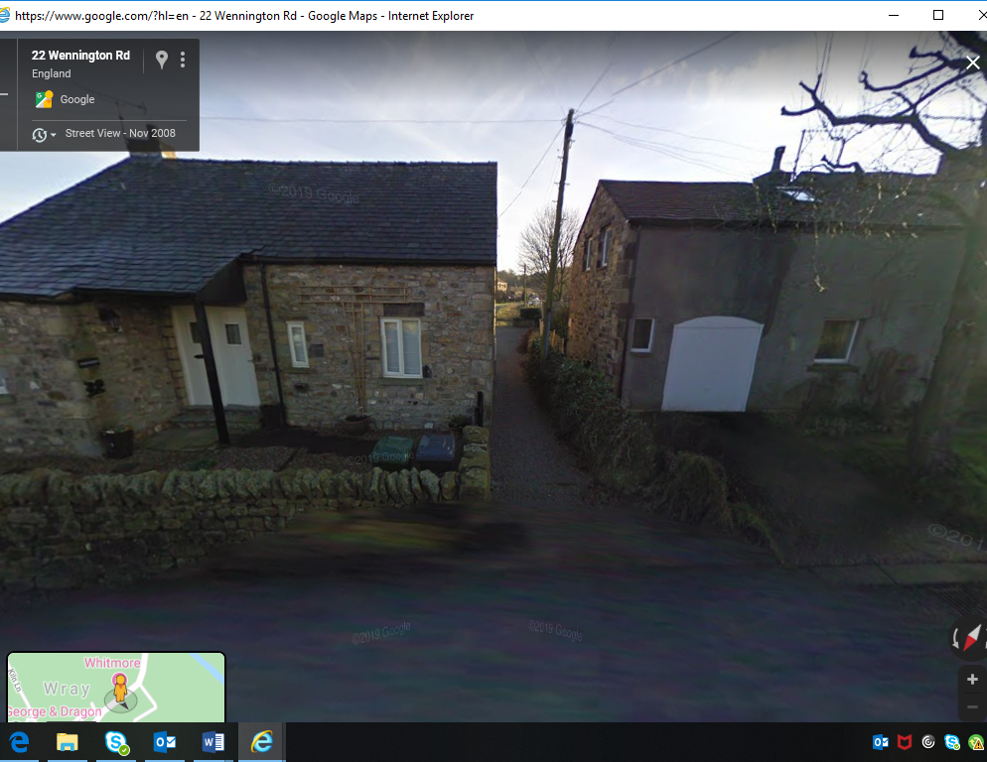
Point A - Image captured in 2008
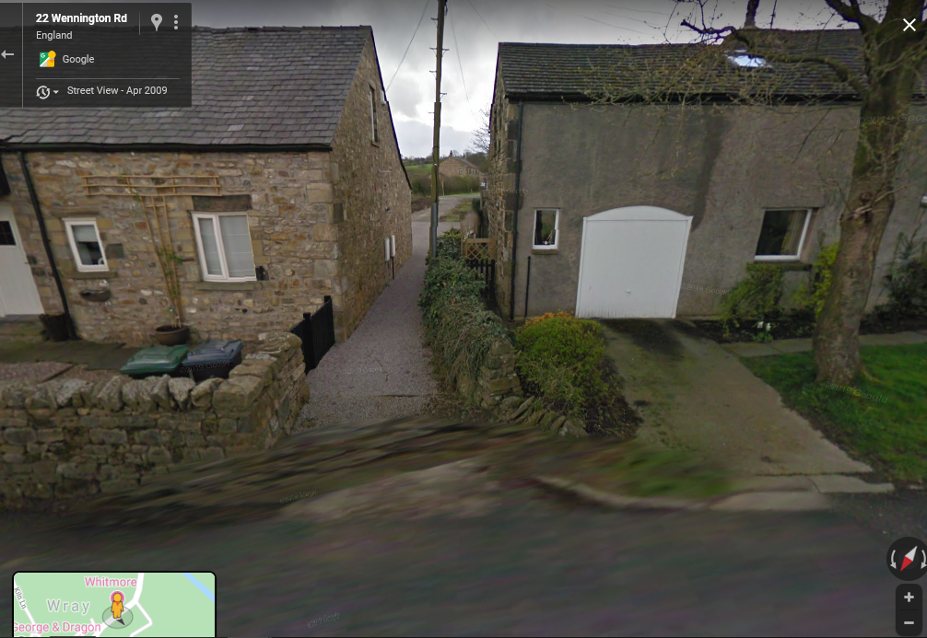
Point A - Image captured in 2009

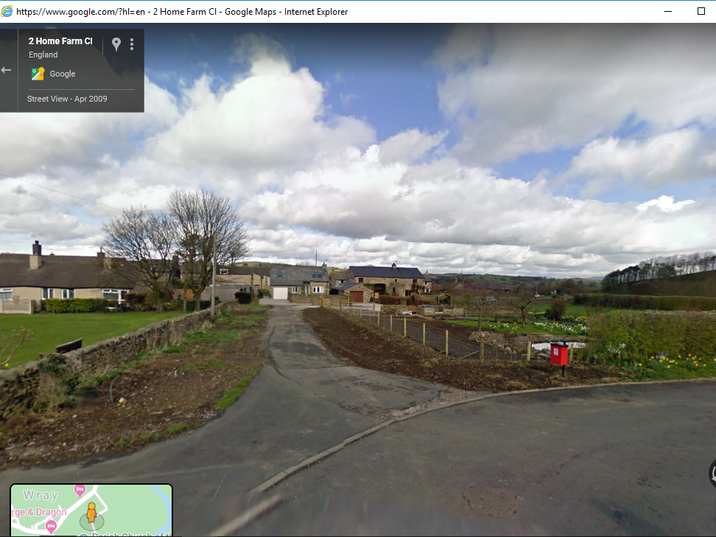
Point C – image captured in 2009
Observations |  | From point A the application route can be clearly seen down the side of 32 Wennington Road in the photographs taken in 2008 and 2009.  Access to the property can be seen from the application route close to point A (gated) but the application route itself appears to be free of any restrictions down the side of the house.  The photograph from point C shows the application route in 2009 as a tarmac road leading up to point B.
Investigating Officer's Comments |  | The application route existed in 2008-2009 and appeared capable of being used.
Definitive Map Records |  | The National Parks and Access to the Countryside Act 1949 required the County Council to prepare a Definitive Map and Statement of Public Rights of Way.  Records were searched in the Lancashire Records Office to find any correspondence concerning the preparation of the Definitive Map in the early 1950s.
Parish Survey Map | 1950-1952 | The initial survey of public rights of way was carried out by the parish council in those areas formerly comprising a rural district council area and by an urban district or municipal borough council in their respective areas. Following completion of the survey the maps and schedules were submitted to the County Council. In the case of municipal boroughs and urban districts the map and schedule produced, was used, without alteration, as the Draft Map and Statement. In the case of parish council survey maps, the information contained therein was reproduced by the County Council on maps covering the whole of a rural district council area. Survey cards, often containing considerable detail exist for most parishes but not for unparished areas.
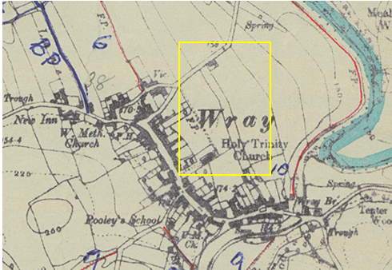
Observations |  | The application route was not shown.
Draft Map |  | The parish survey map and cards for Wray with Botton were handed to Lancashire County Council who then considered the information and prepared the Draft Map and Statement.  The Draft Maps were given a “relevant date” (1st January 1953) and notice was published that the draft map for Lancashire had been prepared. The draft map was placed on deposit for a minimum period of 4 months on 1st January 1955 for the public, including landowners, to inspect them and report any omissions or other mistakes. Hearings were held into these objections, and recommendations made to accept or reject them on the evidence presented.
Observations |  | The application route was not shown on the Draft Map of Public Rights of Way and no representations or objections were made relating to it.
Provisional Map |  | Once all representations relating to the publication of the draft map were resolved, the amended Draft Map became the Provisional Map which was published in 1960, and was available for 28 days for inspection. At this stage, only landowners, lessees and tenants could apply for amendments to the map, but the public could not. Objections by this stage had to be made to the Crown Court.
Observations |  | The application route was not shown on the Provisional Map of Public Rights of Way and no representations or objections were made relating to it.
The First Definitive Map and Statement |  | The Provisional Map, as amended, was published as the Definitive Map in 1962.
Observations |  | The application route was not shown on the First Definitive Map and Statement.
Revised Definitive Map of Public Rights of Way (First Review) |  | Legislation required that the Definitive Map be reviewed, and legal changes such as diversion orders, extinguishment orders and creation orders be incorporated into a Definitive Map First Review. On 25th April 1975 (except in small areas of the County) the Revised Definitive Map of Public Rights of Way (First Review) was published with a relevant date of 1st September 1966. No further reviews of the Definitive Map have been carried out. However, since the coming into operation of the Wildlife and Countryside Act 1981, the Definitive Map has been subject to a continuous review process.
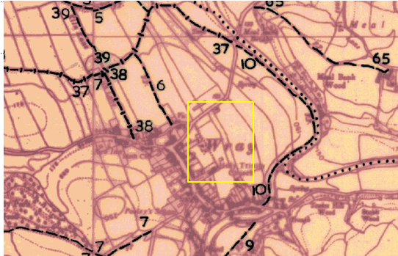
Observations |  | The application route is not shown on the Definitive Map of Public Rights of Way (First Review).
Investigating Officer's Comments |  | From 1953 through to 1975 there is no indication that the application route was considered to be a public footpath by the Surveying authority. There were no objections or representations made regarding the route from the public when the maps were placed on deposit for inspection at any stage of the preparation of the Definitive Map.
Highway Adoption Records including maps derived from the '1929 Handover Maps' | 1929 to present day | In 1929 the responsibility for district highways passed from district and borough councils to the County Council. For the purposes of the transfer, public highway 'handover' maps were drawn up to identify all of the public highways within the county. These were based on existing Ordnance Survey maps and edited to mark those routes that were public. However, they suffered from several flaws – most particularly, if a right of way was not surfaced it was often not recorded.  A right of way marked on the map is good evidence but many public highways that existed both before and after the handover are not marked. In addition, the handover maps did not have the benefit of any sort of public consultation or scrutiny which may have picked up mistakes or omissions.  The County Council is now required to maintain, under section 31 of the Highways Act 1980, an up to date List of Streets showing which 'streets' are maintained at the public's expense. Whether a road is maintainable at public expense or not does not determine whether it is a highway or not.
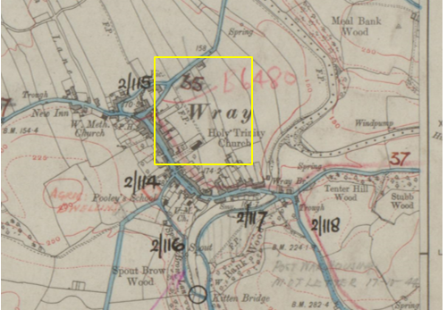
1929 Road Transfer Map
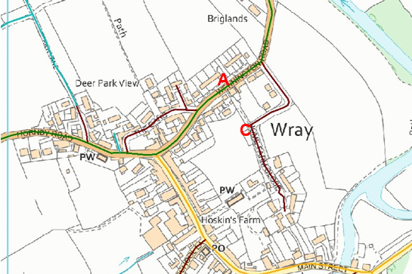
LCC highway classification map
Observations |  | The application route is not recorded as being publicly maintainable on the List of Streets by the county council.  Home Farm Close was adopted on 1 June 2004 with the properties on Home Farm Close (south of the application route) built in approximately 1998-2001 by G and J Developments Limited.
Investigating Officer's Comments |  | No inference can be drawn regarding public rights. By 2004 at the latest the application route provided access to and from publicly maintainable highways (from point A and point C) although before that time it provided access to the playing fields adjacent to point C.
Statutory deposit and declaration made under section 31(6) Highways Act 1980 | 2019-2020 | The owner of land may at any time deposit with the County Council a map and statement indicating what (if any) ways over the land he admits to having been dedicated as highways. A statutory declaration may then be made by that landowner or by his successors in title within ten years from the date of the deposit (or within ten years from the date on which any previous declaration was last lodged) affording protection to a landowner against a claim being made for a public right of way on the basis of future use (always provided that there is no other evidence of an intention to dedicate a public right of way).  Depositing a map, statement and declaration does not take away any rights which have already been established through past use. However, depositing the documents will immediately fix a point at which any unacknowledged rights are brought into question. The onus will then be on anyone claiming that a right of way exists to demonstrate that it has already been established. Under deemed statutory dedication the 20 year period would thus be counted back from the date of the declaration (or from any earlier act that effectively brought the status of the route into question).
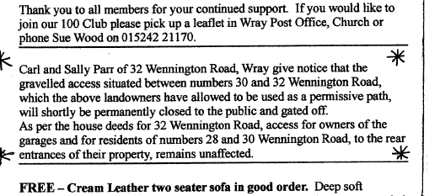
Observations |  | In November 2019 the current owners of 32 Wennington Road posted a notice in the local parish newsletter – the Wrayly Mail – stating that a route (the application route) that they had allowed the public to use as a permissive route was to be permanently closed to the public. Immediately prior to this they had contacted the county council seeking clarification as to whether there was a recorded public right of way across their land.  Following publication of the newsletter the county council received several phone calls and emails regarding the status of the application route and representatives of the Parish Council explained that they their intention to submit an application to record the route as a public footpath.  The owners of the property contacted the county council again in March 2020 requesting information on how to make a statutory declaration and deposit under section 31(6) Highways act 1980. A deposit was submitted to the county council on 1st April 2020 and is currently being processed by Legal and Demographic Services.
Investigating Officer's Comments |  | The current landowner does not acknowledge the existence of public rights along the application route having blocked it off in late 2019 and submitting a statutory deposit and declaration.

The affected land/specified parts of the land is not designated as access land under the Countryside and Rights of Way Act 2000 and is not registered common land.

Landownership

The land crossed by the application route between point A and point B has been in the registered ownership of the owners of 32 Wennington Road since 2010.

The land crossed by the application route between point B and point C has been in the registered ownership of Wray Parish Council (the applicants) since 2010.

Summary

No map and documentary evidence supporting the existence or use of the application route prior to the 1960s has been found.

The application route existed in the 1960s - as evidenced by the aerial photograph from that time - as part of a longer access road providing direct access to Home Farm.

A Grant of Deed dated 1970 relates to private access along the application route to gain access to a school field and a supplementary agreement dated 1995 diverted this private right to the route now forming part of Home Farm Close. The 1995 plan indicates that pedestrian access was to be retained at point A and both the 1970 and 1995 plans indicate that access may have been possible along the application route during that time although neither agreement conveyed public rights of access on foot.

The application route is clearly shown as part of the access road referred to in the 1970 grant on the OS map published in 1973 and access appears to have continued beyond point C through Home Farm out to Main Street.

When residential properties were built on the farm site in the late 1990s then the original farm access track was re-routed to the alignment of Home Farm Close which was constructed as part of the development and included use of the private access road constructed following the private agreement made by Mrs Holt and the county council. The original access from point A was retained as a pedestrian link – as clearly specified in the grant of planning permission for the construction of 32 Wennington Road dated 1999 – and appears to have been accessible until its use was challenged in 2019.

Head of Service – Legal and Democratic Services Observations

Information from the Applicant

In addition to the documentary evidence already presented four user evidence forms were submitted in support of the application, this user evidence is summarised below.

Duration of Use

The user evidence forms collectively provide evidence of use going back as far as 1970 and up to 2020. Of the four users three record use of the route for 20 years before the route was called into question in 2019.

Frequency of Use

Three of the users stated weekly use on foot whilst one stated use every few months on foot.

Reasons for Use

One of the users noted use for pleasure, the three other users all noted use to access the local children's playground with children, to access the local playing fields for village events or to access other parts of the village.

One user noted that they had a private right to use the route granted in the deeds to their own property.

Other Users of the Route

All users noted seeing others using the route on foot, in addition one also noted use by people with pushchairs, occasional use by people in wheelchairs and use by motor vehicles.

Consistency of the Route

Three of the users specified that the application route had always followed the same route, one did not specify.

Unobstructed Use of the Route

One user stated that they had never seen any signs, notices, or encountered any barriers and had not been prevented from using the route.

Two other users noted closure of the route in June of 2019, one specifying the route was closed for 3 weeks at this time. Both also noted that the route was closed in February and April of 2020. Both made mention of a notice published in the parish newsletter, the Wrayly Mail, in 2019 stating that the route was not a public right of way and went on to note that the owners had directly communicated that the route was not a public right of way by email and speaking in person respectively.

These two users also noted another resident of the village who had previously used the route being told directly that the intended closure of the route applied to her.

The remaining user noted the installation of a gate but noted this had not prevented use of the route though they believe this to be the owner's intention. They noted that the user now states that the route is not public.

Information from Others

Several utilities providers responded to the consultations to state they had no objection to the application but no further information was provided.

Information from the Landowner

The owners of 32 Wennington Road responded to the consultation confirming their land ownership. They stated that the house was built in the year 2000 and they purchased the property in February of 2010. They highlighted that the property is listed as being of one of 'special interest'. Their understanding is that their property sits on what was once an unmade farm track which led from Wennington Road through to Home Farm, Main Street, Wray.

The owners noted the deed of grant dated 2nd April 1970 which was provided to them by Wray with Botton Parish Council stating that this deed grants access rights to Lancashire County Council, but no other person(s) are granted access.

The owners went on to object to the application on several points.

- That the land in their ownership is the subject of a deposit under section 31(6)Highways Act 1980 and 15A(1) Commons Act 2006 lodged with Lancashire County Council on 1st April 2020.

- Since their occupation of 32 Wennington Road the access in question has been closed to the public on several dates; Sunday 6th February 2011, Friday 6th February 2015, Saturday 1st June to Monday 10th June 2019 inclusive, Thursday 6th February 2010 and from Thursday 2nd April to Sunday 5th July 2020 inclusive during the 'Iockdown'.

- They noted that the Parish Council have placed great emphasis on paragraph 13 of a Lancaster City Council letter dated 18th October 1999 which relates to an amendment application dated 1st October 1999 in respect of the original planning permission for the building of 32 Wennington Road, Wray. Paragraph 13 states that a pedestrian access must be maintained to a minimum of 2 metres from Wennington Road to land to the south of the site.

The landowner stated that they had taken several measurements from the building line of 32 Wennington Road to the boundary wall of 30 Wennington Road with the route actually varying in width from a maximum of 1.9m to a minimum of 1.6m. They therefore suggest that the clause at paragraph 13 is null and void. They noted that Lancaster City Council planning have been informed of this fact and asked for their observations but no response had been received. The owners went on to highlight a Land Registry document dated 25th November 1999 that shows the access to be only 1.8m wide and that such access is for garage users only. A copy of this document was requested and provided, extracts are shown below.
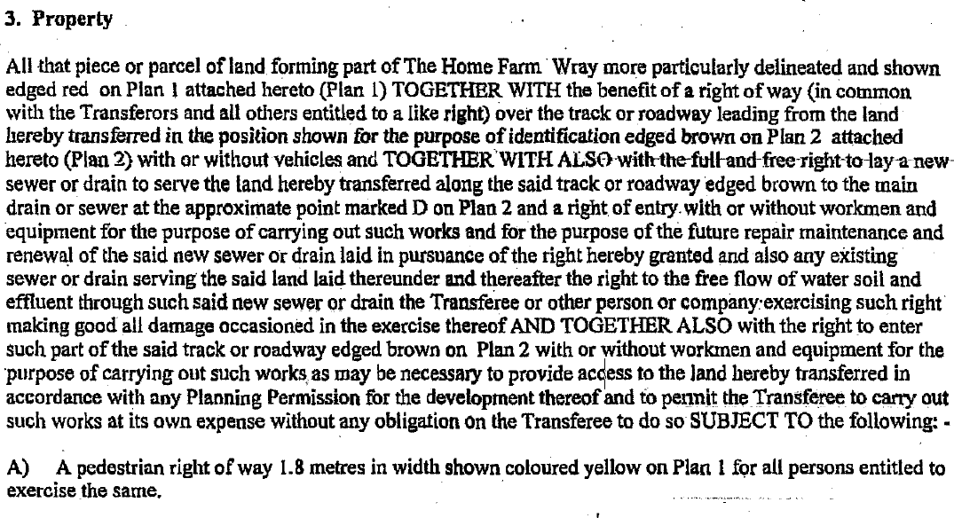
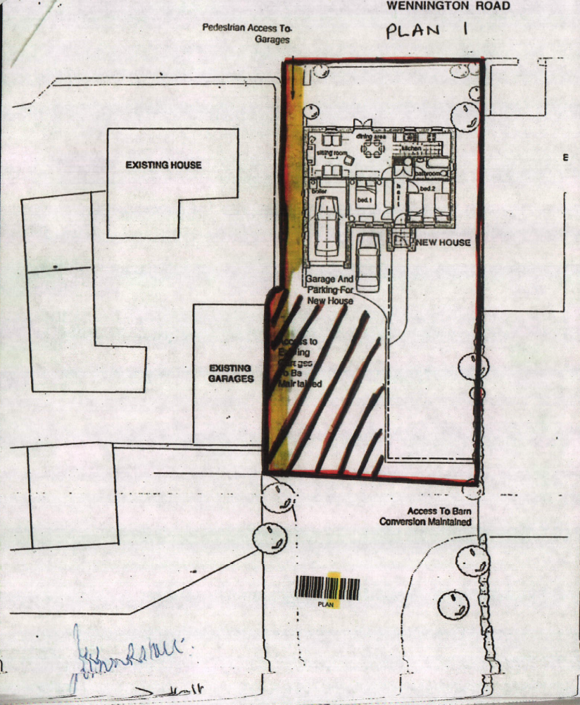

- The owners stated that the whole of the land in question is not suitable for designating as a Public Footpath as it is primarily used for vehicle access, manoeuvring and parking whilst the Wennington Road end of the route opens directly onto the carriageway of the busy B6480 at a point where there is no footway on either side of the road. They state that safer and alternate access to both the school field and Home Farm Close are easily available.

- They note that a precedent was set when, following its redevelopment, the opposite end of the former Home Farm track leading onto Main Street, Wray was, despite its use by the public as a cut through, closed off and gated. The owners state that date of this is not known but that it took place within the last 20 years.

- The owners assert that "granting of a Public Footpath" at this location would possibly have a negative impact on the future sale values of both 32 and 30 Wennington, Road, Wray or make the properties more difficult to sell.

Assessment of the Evidence

The Law - See Annex 'A'

In Support of Making an Order(s)

- Some user evidence.
- Absence of signs and notices along the route stating that the route was not public.
- Absence of action taken by landowners to discourage use of the route.
- Map and other documentary evidence supporting the physical existence of the route since at least the 1960's.
- Part of the application route is (B-C) is owned by the applicants for the order.

Against Making an Order(s)

- Low number of user evidence.
- Action taken by current landowners of part of the route in 2019 to stating the route was permissive and would be closed which would set a date for S31 dedication and suggest no common law dedication during the current ownership.

Conclusion

The application is that the route A-B-C has already become a footpath in law and should be recorded on the Definitive Map and Statement of Public Rights of Way.

As there is no express dedication Committee should consider, on balance, whether there is sufficient evidence from which to have its dedication inferred at common law from all the circumstances or for the criteria in section 31 Highways Act 1980 for a deemed dedication to be satisfied based on sufficient twenty years "as of right" use to have taken place ending with this use being called into question.

Considering initially whether there are circumstances from which dedication could be inferred at common law. It is advised that Committee has to consider whether evidence from the maps and other documentary evidence coupled with user evidence indicates that it can be reasonably inferred that in the past the landowner(s) intended to dedicate the route as a public right of way.

The analysis of the map and documentary evidence indicates that the route did not physically exist prior to 1960. The route was part of a wider access from Wennington Road to Main Street through Home Farm.

Sufficient as of right use agreed by the owners may be circumstances from which dedication can be inferred. Significantly, planning permission granted in 1999 to construct number 32 Wennington Road contains a planning condition requiring a public pedestrian access to be maintained from Wennington Road to the land to the south of the site. This route was to be a minimum of 2 metres wide, which is the generally accepted width required for the creation or diversion of a public footpath, however it is acknowledged that public footpaths can be accepted measuring less than 2 metres in width.

The planning permission demonstrates that at such time it was considered that a public route already existed and the Local Planning Authority intended for such to be maintained despite the new house being development around it. In addition the planning condition was seemingly accepted by the planning applicant as the condition was never removed or relaxed. As the route continued to be open and available (all be it slightly less than 2 metres in width) the condition was arguably complied with and the users state that they continued to use the route after the construction of the new dwelling up until 2019. Such action demonstrates that in 1999 the planning applicants had knowledge of the public using the route and further showed a willingness to allow the public to continue to use the informal footpath. The breach of planning condition 13 is an issue for the Lancaster City Council as the Local Planning Authority to consider and carryout the necessary enforcement action should they feel it appropriate.

The landowners suggest that part of the route A-B is not suitable as a public footpath as the route is primarily used for vehicular access; however, Committee is reminded that such suitability of a route and the existence of an alternative are not matters to be taken into account when determining the existence of a public right of way. Equally the negative impact on the value of a property although of concern to landowners is not a matter which the Committee can consideration. Finally, the owners of the section of route A-B make comparisons to a precedent having been set for a similar route located the opposite site of Home Farm, Committee is reminded that each route is to be considered on its own evidence and that other routes cannot be used as comparisons.

The four users present evidence that there has never been any clear action by owners to prevent use by the public and use by the public has continued for many years such that, on balance, there may be sufficient evidence from which to infer dedication at common law. The current landowners of part of the route A- B have indicated in a letter to Lancashire County Council that the section of route A-B has been closed off on four separate occasions between 1999 and 2019, however, the applicants and the users have not indicated any knowledge of such closures in their user evidence.

Looking next at the criteria for a deemed dedication under section 31 of the Highways Act 1980, use of the route needs to be by the public 'as of right' (without force, secrecy or permission) and without interruption over a sufficient 20 year period immediately prior to the route being called into question. In this matter, the evidence indicates that access to the route was obstructed in 2019; therefore, the 20-year period under consideration for the purposes of establishing deemed dedication would therefore be 1999-2019.

The applicant has provided four user evidence forms in support of the application, which refer to use of the route from as early as 1970. Three users provide evidence of use during the period under consideration. All users have referred to having witnessed other users whilst using the route themselves. Three of the users claim to have used the route on foot weekly and one user claims to have used the route monthly, and three users claim to have used the route 'as of right' with one user claiming to use the route via a private right granted in his property title deeds.

None of the users recall having ever been told that the route was not a public right of way, prior to 2019 nor do any users refer to having been turned back or having asked permission to use the route. It is therefore suggested that there is sufficient evidence of use of the claimed route by the public as of right to raise a presumption of dedication for the period 1999-2019.

Committee's attention is drawn to the fact that three of the four users claim to have used the route as of right, which can be viewed as a relatively low number. Committee should however note that the Applicant in this instance is the local Parish Council who are themselves representatives of the Wray Villagers. However, Guidance from the Planning Inspectorate indicates that use of the route must be by a sufficient number of people who together may sensibly be taken to represent the public at large. Committee may consider that three users of the route are not representative of the public at large and therefore the evidence does not raise a presumption of dedication of a footpath and fails to satisfy the statutory test.

The current owner of the land crossed by the route between point A and point B has submitted a Statutory Declaration under section 31(6) Highways Act 1980 to Lancashire Council dated 1st April 2020. Section 31(6) of the Highways Act 1980 enables landowners to protect themselves against public rights of way coming into existence, based solely on a period of use by the public but this only protects them from use of the route following submission of the declaration i.e. post 1st April 2020.

In conclusion, taking all of the evidence into account, the Committee on balance may consider that the provisions of section 31 of the Highways Act 1980 can be satisfied. In addition, or in the alternative, Committee may also consider that it can be reasonably alleged that there is sufficient evidence from which to infer dedication of a public footpath at common law.

Committee is therefore advised to accept the application, make an Order and promote the Order to confirmation.

Risk management

Consideration has been given to the risk management implications associated with this claim. The Committee is advised that the decision taken must be based solely on the evidence contained within the report, and on the guidance contained both in the report and within Annex 'A' included in the Agenda Papers. Provided any decision is taken strictly in accordance with the above then there is no significant risks associated with the decision making process.

Local Government (Access to Information) Act 1985

List of Background Papers

Paper | Date | Contact/Directorate/Tel
All documents on File Ref: 804-620 |  | Simon Moore, 01772 531280, County Secretary and Solicitors Group
Reason for inclusion in Part II, if appropriate

N/A

The Ordnance Survey (OS) has produced topographic maps at different scales (historically one inch to one mile, six inches to one mile and 1:2500 scale which is approximately 25 inches to one mile). Ordnance Survey mapping began in Lancashire in the late 1830s with the 6-inch maps being published in the 1840s. The large scale 25-inch maps which were first published in the 1890s provide good evidence of the position of routes at the time of survey and of the position of buildings and other structures. They generally do not provide evidence of the legal status of routes, and carry a disclaimer that the depiction of a path or track is no evidence of the existence of a public right of way.
Aerial photographs can show the existence of paths and tracks, especially across open areas, and changes to buildings and field boundaries for example. Sometimes it is not possible to enlarge the photos and retain their clarity, and there can also be problems with trees and shadows obscuring relevant features.

